# Ssccoorriinngg – update 04 / 05/ 20

* Dataset: 40 healthy subjects (LORETA data)
* Leave-one-out CV
* Single channel EEG (F4 – M1)
* Time-dependency added (these results are based on adding 6 preceding and proceeding epochs)
* Changes in feature extraction: Wavelet decomposition up to level 4.
* Current results (excluding any probable NaN):

|  |  |  |  |  |  |
| --- | --- | --- | --- | --- | --- |
|  | Wake | N1 | N2 | SWS | REM |
| Accuracy (%) | 96.65 | 88.67 | 82.94 | 93.43 | 89.66 |
| Precision (%) | 90.05 | 84.18 | 83.35 | 89.19 | 72.14 |
| Recall (%) | 63.28 | 07.81 | 79.33 | 71.57 | 52.52 |
| F1-score (%) | 71.46 | 14.79 | 79.19 | 76.22 | 60.25 |

* Example of an acceptable prediction:

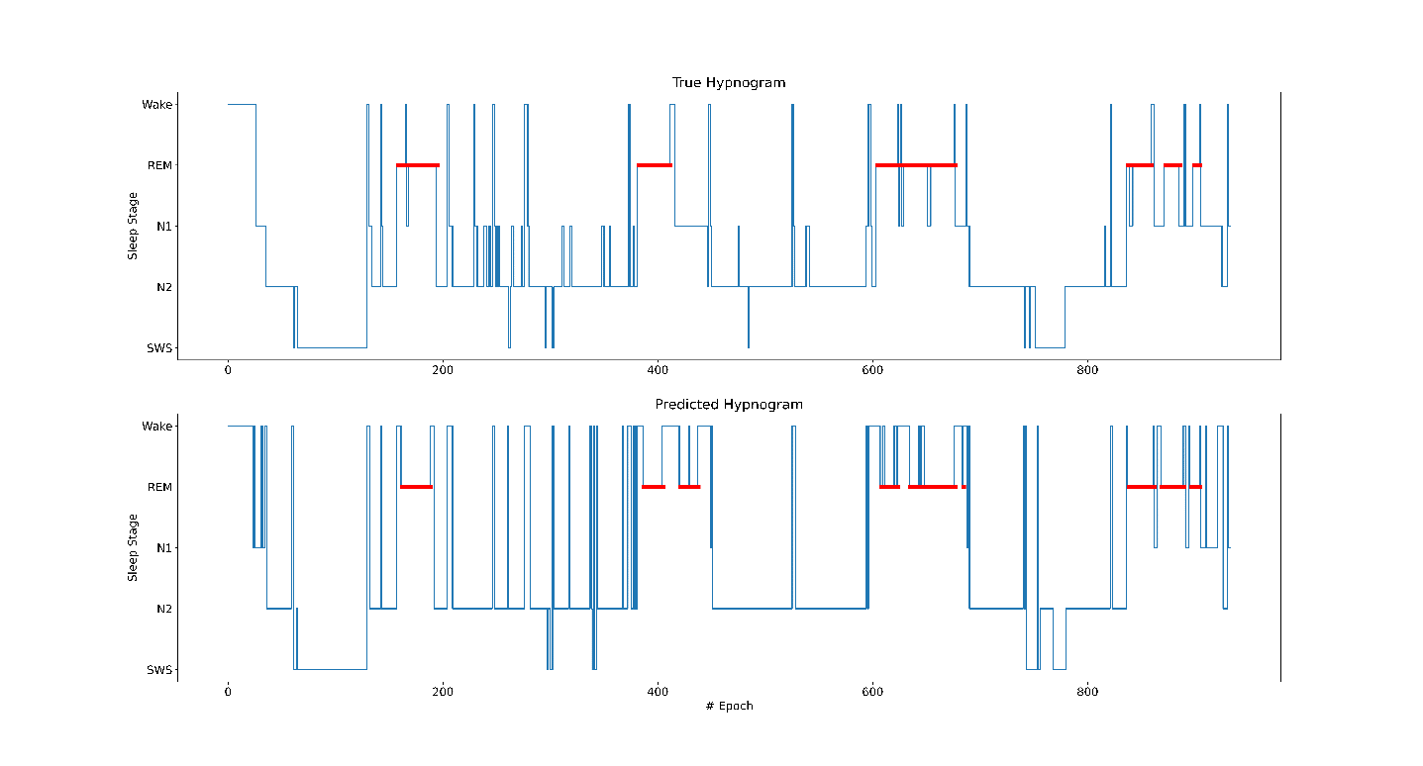

Plans for this week:

* Add features from EMG, EOG, ECG.
* Look up for methods how to improve N1 detection metrics.

# Ssccoorriinngg – update of 05 / 05 / 20

* Replacing LOOCV with a broader test split (N_tr = 30, N_ts = 10)
* Looking into both F4-M1 as the preliminary investigational channel and Fp1-Fp2 as the main target.
* We checked the RF models with 250, 500, and 750 trees.

Table 1 - N_trees = 250.

|  |  |  |  |  |  |  |  |  |  |  |
| --- | --- | --- | --- | --- | --- | --- | --- | --- | --- | --- |
|  | Wake | | N1 | | N2 | | SWS | | REM | |
| **F4-M1** | **Fp1-Fp2** | **F4-M1** | **Fp1-Fp2** | **F4-M1** | **Fp1-Fp2** | **F4-M1** | **Fp1-Fp2** | **F4-M1** | **Fp1-Fp2** |
| Accuracy (%) | 97.18 | 97.29 | 86.72 | 86.74 | 81.65 | 81.60 | 94.84 | 94.87 | 88.39 | 88.20 |
| Precision (%) | 92.35 | 92.12 | 52.33 | 53.84 | 82.04 | 81.85 | 88.37 | 89.37 | 76.07 | 75.90 |
| Recall (%) | 61.56 | 63.60 | 03.72 | 03.47 | 78.72 | 78.88 | 79.74 | 78.82 | 38.43 | 36.76 |
| F1-score (%) | 73.88 | 75.25 | 06.94 | 06.52 | 80.34 | 80.34 | 83.83 | 83.76 | 51.06 | 49.52 |

Table 2 - N_tress = 500.

|  |  |  |  |  |  |  |  |  |  |  |
| --- | --- | --- | --- | --- | --- | --- | --- | --- | --- | --- |
|  | Wake | | N1 | | N2 | | SWS | | REM | |
| **F4-M1** | **Fp1-Fp2** | **F4-M1** | **Fp1-Fp2** | **F4-M1** | **Fp1-Fp2** | **F4-M1** | **Fp1-Fp2** | **F4-M1** | **Fp1-Fp2** |
| Accuracy (%) |  | 95.16 |  | 86.74 |  | 81.90 |  | 92.56 |  | 89.22 |
| Precision (%) |  | 76.06 |  | 61.54 |  | 80.56 |  | 81.42 |  | 78.18 |
| Recall (%) |  | 36.73 |  | 01.32 |  | 81.75 |  | 72.13 |  | 43.81 |
| F1-score (%) |  | 49.54 |  | 02.59 |  | 81.15 |  | 76.50 |  | 56.16 |

Table 3 - N_trees = 750.

|  |  |  |  |  |  |  |  |  |  |  |
| --- | --- | --- | --- | --- | --- | --- | --- | --- | --- | --- |
|  | Wake | | N1 | | N2 | | SWS | | REM | |
| **F4-M1** | **Fp1-Fp2** | **F4-M1** | **Fp1-Fp2** | **F4-M1** | **Fp1-Fp2** | **F4-M1** | **Fp1-Fp2** | **F4-M1** | **Fp1-Fp2** |
| Accuracy (%) |  | 95.10 |  | 86.81 |  | 82.16 |  | 92.48 |  | 89.14 |
| Precision (%) |  | 75.44 |  | 73.08 |  | 80.72 |  | 81.14 |  | 77.64 |
| Recall (%) |  | 36.05 |  | 01.57 |  | 82.21 |  | 71.93 |  | 43.67 |
| F1-score (%) |  | 48.79 |  | 03.07 |  | 81.46 |  | 76.26 |  | 55.90 |

Table 4 - N_trees = 1000.

|  |  |  |  |  |  |  |  |  |  |  |
| --- | --- | --- | --- | --- | --- | --- | --- | --- | --- | --- |
|  | Wake | | N1 | | N2 | | SWS | | REM | |
| **F4-M1** | **Fp1-Fp2** | **F4-M1** | **Fp1-Fp2** | **F4-M1** | **Fp1-Fp2** | **F4-M1** | **Fp1-Fp2** | **F4-M1** | **Fp1-Fp2** |
| Accuracy (%) |  | 95.13 |  | 86.78 |  | 81.98 |  | 92.50 |  | 89.17 |
| Precision (%) |  | 76.44 |  | 72.73 |  | 80.77 |  | 81.17 |  | 77.97 |
| Recall (%) |  | 35.88 |  | 01.32 |  | 81.63 |  | 72.07 |  | 43.54 |
| F1-score (%) |  | 48.84 |  | 02.60 |  | 81.20 |  | 76.35 |  | 55.87 |